Board of Directors

Associated British Foods Plc

The following are extracts from the 2019 Annual Report of Associated British Foods PLC.
  - Introduction to the Company
Associated British Foods PLC is a leader in grocery, agriculture and retail products in the UK. The grocery brands occupy leading positions in markets across the globe. In the UK, nine out of ten households use its brands.
- Agri, a subsidiary of Associated British Foods PLC, is the UK’s largest agri-food company and a leader in nutrition, science and technological innovation in animal feed.
- Primark, which is another subsidiary, is the largest clothing, footwear and accessories retailer in the UK, and also has a significant store portfolio in ten European countries and in the US.
  - Board of Directors
The following structure shows directors on the Board of directors and its subcommittees.
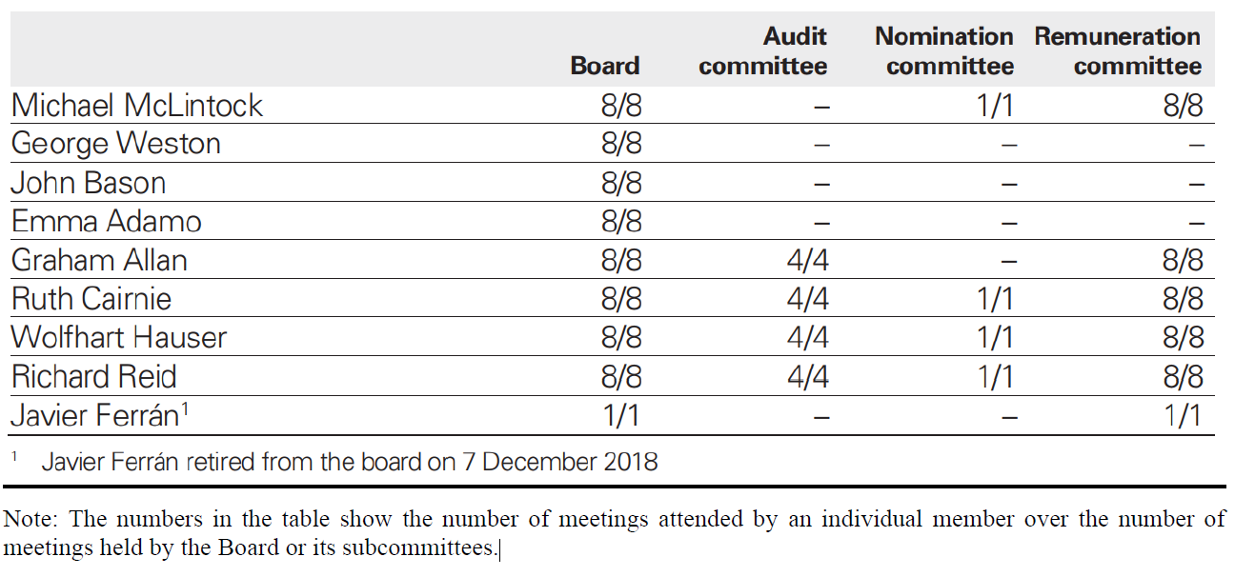
At the date of this report, the Board comprises the following directors:
- Chairman: Michael McLintock
- Executive directors: George Weston (Chief Executive) and John Bason (Finance Director)
- Non-executive directors: Emma Adamo; Graham Allan; Ruth Cairnie; Wolfhart Hauser; and Richard Reid
  - Director Biographies
Michael McLintock. Michael was appointed a director in November 2017 and Chairman in April 2018. He was formerly chief executive of M&G, retiring in 2016, having joined the Company in 1992 and been appointed chief executive in 1997. In 1999 he oversaw the sale of M&G to Prudential plc where he served as an executive director from 2000 until 2016. Previously he held roles in investment management at Morgan Grenfell and in corporate finance at Morgan Grenfell and Barings.
George Weston. George was appointed to the Board in 1999 and took up his current appointment as Chief Executive in April 2005. In his former roles at Associated British Foods, he was Managing Director of Westmill Foods, Allied Bakeries and George Weston Foods Limited (Australia).
John Bason. John was appointed as Finance Director in May 1999. He has extensive international business experience and in-depth knowledge of the industry. He was previously the finance director of Bunzl plc and is a member of the Institute of Chartered Accountants in England and Wales.
Emma Adamo (female). Emma was appointed a director in December 2011. She was educated at Stanford University and had an MBA from INSEAD in France.
Graham Allan. Graham was appointed a director in September 2018. Graham was formerly the Group Chief Executive of Dairy Farm International Holdings Limited, a pan-Asian retailer and a subsidiary of Jardine Matheson, until August 2017 after serving five years with the group. Prior to joining Dairy Farm, he was President and Chief Executive Officer at Yum! Restaurants International and was responsible for global brands KFC, Pizza Hut and Taco Bell in all markets except the US and China. Since 1989, Graham has held various senior positions in multinational food and beverage companies with operations across the globe and has lived and worked in Australia, Asia, the US and Europe.
Ruth Cairnie (female). Ruth was appointed a director in May 2014 and has been Senior Independent Director since 7 December 2018. Ruth was formerly Executive Vice President of Strategy & Planning at Royal Dutch Shell plc. This role followed a number of senior international roles within Shell, including Vice President of its Global Commercial Fuels business. Ruth has also held a number of non-executive directorships including on the boards of Keller Group plc and ContourGlobal plc.
Wolfhart Hauser. Wolfhart was appointed a director in January 2015. Starting his career with various research activities, he went on to establish and lead a broad range of successful international service industry businesses. He was Chief Executive of Intertek Group plc for ten years until he retired from that role and the Board in May 2015. He was previously Chief Executive Officer and President of TÜV Süddeutschland AG for four years and Chief Executive Officer of TÜV Product Services for ten years. He has also held other directorship roles, including as a non-executive director of Logica plc from 2007 to 2012 and Chair of FirstGroup plc for four years from 2015 to July 2019.
Richard Reid. Richard was appointed a director in April 2016. He was formerly a partner at KPMG LLP (‘KPMG’), having joined the firm in 1980. From 2008, Richard served as London Chairman at KPMG until he retired from that role and KPMG in September 2015. Previously, Richard was KPMG’s UK Chairman of the High Growth Markets group and Chairman of the firm’s Consumer and Industrial Markets group.
  - Board’s Leadership
The Board of directors is collectively responsible to the Company’s shareholders for the direction and oversight of the Company to ensure its long-term success. The Board met regularly throughout the year to approve the group’s strategic objectives, to lead the group within a framework of effective controls which enable risk to be assessed and managed, and to ensure that sufficient resources are available to meet the objectives set.

  - Senior Independent Director
The purpose of this role is to act as a sounding board for the Chairman and to serve as an intermediary for other directors where necessary. The Senior Independent Director is also available to shareholders should a need arise to convey concerns to the Board, which they have been unable to convey through the Chairman or through the executive directors.
  - The non-executive directors
The non-executive directors, in addition to their responsibilities for strategy and business results, play a key role in providing a solid foundation for good corporate governance and ensure that no individual or group dominates the Board’s decision-making. They each occupy or have occupied, senior positions in industry which, taken together, cover a broad range of jurisdictions, bringing valuable external perspective to the Board’s deliberations through their experience and insight from different sectors and geographies. This enables them to contribute significantly to board decision-making, whilst the small size of the Board is conducive to open and candid discussions. The formal letters of appointment of non-executive directors are available for inspection at the Company’s registered office.
  - Board independence
Emma Adamo is not considered by the Board to be independent in view of her relationship with Wittington Investments Limited, the Company’s majority shareholder. She was appointed in December 2011 to represent this shareholding on the Board of the Company. The Board considers that the other non-executive directors are independent in character and judgement and that they are each free from any business or other relationships which would materially interfere with the exercise of their independent judgement.
The Board considered Richard Reid’s independence by reference to the relevant provisions of the UK Corporate Governance Code and concluded that he is independent notwithstanding his past relationship with KPMG, which was formerly the group’s auditor. It has now been four years since KPMG ceased to be the Company’s auditor in November 2015, following a competitive tender for the external audit. Richard was formerly a partner at KPMG, retiring from that role in September 2015. He had no personal engagement with any business within the Associated British Foods group during the four years prior to his appointment by the Company in April 2016.
As at the date of this report, the Board comprises the Chairman, Chief Executive, Finance Director and five non-executive directors.
  - Information flow
The Company Secretary manages the provision of information to the Board at appropriate times in consultation with the Chairman and Chief Executive. In addition to formal meetings, the Chairman and Chief Executive maintain regular contact with all directors. The Chairman holds informal meetings with non-executive directors, without any of the executives being present, to discuss issues affecting the group, when appropriate. Regular management updates are sent to directors to keep the non-executive directors informed of events throughout the group between board meetings and to ensure that they are advised of the latest issues affecting the group.

